Name _____________________ Local School Governance Team (LSGT) ___________________

“Pulse Check” on School Operations
Directions: Select the best answer by choosing a, b, c, or d.

- In a typical school system organizational chart, which Assistant Superintendent is relevant to school operations?
  - Assistant Superintendent for Instructional Services
  - Assistant Superintendent for Business Operations
  - Assistant Superintendent for Human Resources
  - None of the above
- Which of the following is typically NOT a function of the Office of Business Operations?
  - Plant services and custodial operations
  - Safety and Energy
  - Student Services
  - School Nutrition

- Which of the following school operations are governed by the SPLOST, Facility Planning, and Construction function of the Office of Business Operations?
  - Build facilities and acquire technologies that support the educational process in our schools both today and in the future
  - Design and construct facilities that provide safe and secure learning environments
  - Incorporate energy conservation and use of sustainable materials in facility design
  - All of the above

- At the district and school level, many school systems conduct room by room safety inspections and review site preparedness-protocols. This typically occurs
  - Each semester
  - Each year
  - Every 2 years
  - Every month

- The Emergency Operations Plan includes
  - Fire drills
  - Severe weathers drills
  - School lockdown procedures
  - All of the above

- Which element below is NOT part of the district and school-based framework for secure campuses and workplaces?
  - Environmentally friendly custodial practices
  - Local law enforcement officials
  - Emergency operations plan
  - Notification protocol

- As part of ensuring secure campuses, many school districts design schools that
  - Have two entrances that direct visitors to the side of the school they need to access
  - Encourage parents to visit students without checking in at the front office
  - Discourage surveillance camera system use
  - Are equipped with a security vestibule that physically directs visitors to the front office and restricts access into the rest of the building

- The Student Code of Conduct
  - Contributes to a safe school environment
  - Is designed to support a learning process where students are fully engaged
  - Describes disciplinary actions and procedures
  - All of the above

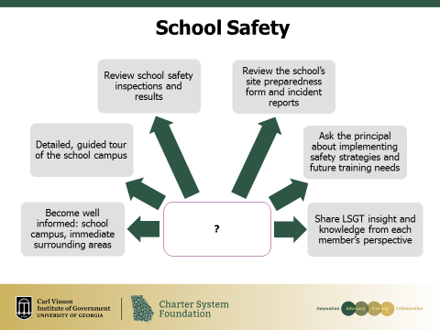

- The graph above represents
  - The security process
  - The awareness process
  - The intrusion process
  - None of these

