Guide to
Dual Enrollment Graduation
Option B

Dan Weber, Executive Director
May 4, 2021
dan@charter-system.org

Contents
Section 1: OVERVIEW OF OPTION B 2
1.1 Requirements 2
1.2 How Much does a Student Pay for Option B? 2
1.3 Why is Option B Important to Georgia? 3
1.4 Overview Videos and Presentations 3
Section 2: IMPLEMENTATION 5
Section 3: OPTION B LEGAL REQUIREMENTS 6
3.1 Senate Bill 2 6
3.2 State Board Dual Enrollment Rule Option B 8
3.3 Requirement of Nine (9) High School Courses 9
3.4 Requirement of Postsecondary Credential 10
3.5 List of TCCs Approved by TCSG 11
Section 4: FIELDS OF STUDY TO MEET EMPLOYER NEEDS 15
4.1 General 15
4.2 Best Practices from Option B Districts 16
Section 5: SCHEDULING 22
5.1 Scheduling Nine (9) High School Courses 22
5.2 Scheduling Postsecondary Courses 26
Section 6: RECRUITMENT AND COUNSELING 35
6.1 Video Resources 35
6.2 The Role of Counselors 35
6.3 Counselor Checklists 36
6.4 Recruiting Option B Students 43
6.5 “Best Dropout Prevention Tool” 45
6.6 “Pathway to College” 46
Section 7: FUNDING 47

Section 1: OVERVIEW OF OPTION B

Requirements

Based on Senate Bill 2 passed in 2015, the State Board amended its Dual Enrollment Rule to provide that a student at a public high school may take postsecondary courses through dual enrollment to earn a high school diploma either by:
- Option A: Completing postsecondary academic courses that satisfy normal high school graduation requirements, or
- Option B: Completing nine (9) high school courses and earning a career-oriented postsecondary credential.
OPTION B REQUIREMENTS
Complete 9 High School Courses  2 English (American Lit w/EOC for 2022 Grads & Beyond)  2 Math (Algebra 1 or Coordinate Algebra w/EOC)  2 Science (Biology w/EOC)  2 Social Studies  1 Health/PE course | Earn a Postsecondary credential:  (Choose one)  Any Associate Degree, or  Any Technical College Diploma, or  2 Technical College Certificates (TCC) in an approved career pathway. (see Section 3.5 below for list of TCCs approved by TCSG)

1.2 How Much does a Student Pay for Option B?

The state pays for all or most of the cost of the postsecondary courses through dual enrollment or the HOPE Grant/HOPE Career Grant. A student can graduate debt-free with these postsecondary credentials. Starting salaries in high-demand fields range from $30,000 to $50,000.

1.3 Why is Option B Important to Georgia?

In Georgia, over 50,000 job openings go unfilled each year for workers with postsecondary credentials that an Option B high school student can earn.
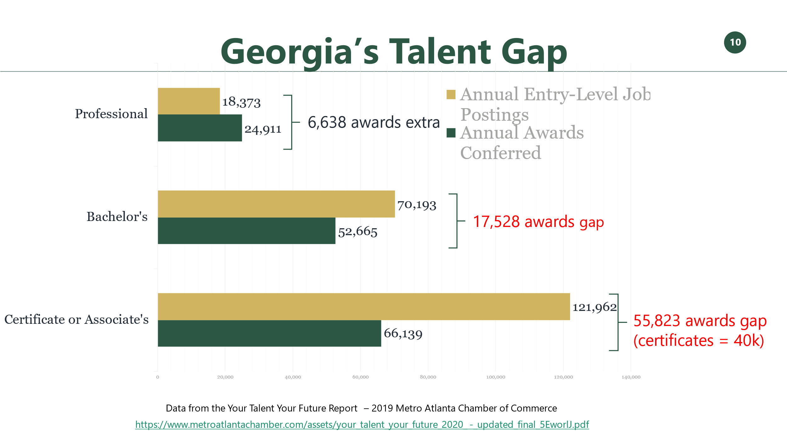

1.4 Model PowerPoint Slides and Overview Webinars/Presentations

The Foundation has compiled a Model PowerPoint with slides designed to explain Option B pathways in a graphical format. The Model PowerPoint has been reviewed by TCSG, DOE and GSFC and we have incorporated suggested changes. You could incorporate these model slides, as you deem appropriate, in various presentations to students, parents, staff, counselors, community groups and employers. Some of the slides could also be used as handouts by counselors when meeting one-on-one with students and/or parents. The Model PowerPoint can be downloaded from the Option B Resource Center, or here is a link: Model PPT Option B 9-2-21.pptx
Here are links to presentations that may be of interest to gain an overview of Option B:
- Option B “Overview” Webinar with Panel Discussion from January 28, 2021
Watch webinar:
https://youtu.be/tA0pxb5rgZg January 28, 2021 (note that the first part of this webinar was not recorded)

Download PowerPoint:
Dual Enrollment Graduation Option-B-PPT-1-28-2021

- “Dual Enrollment” presentation (21 min) by Dianne Barker, Director, Secondary Initiatives Dual Enrollment, TCSG, as part of March 4, 2021 “Funding and Programs of Study” Webinar.

Watch webinar: https://www.youtube.com/watch?v=uDu1oGdY8jk&t=2344s

Download PowerPoint:
TCSG Option B Presentation

Section 2: IMPLEMENTATION

We recommend that your district designate one person (“Option B Coordinator”) who will be responsible for coordinating and leading the implementation of your district’s Option B program. Implementing an Option B program is time consuming, so be sure to choose someone who can dedicate a significant amount of time.
The Option B Coordinator should consider forming a task force and schedule regular meetings to help with the implementation. The task force could include one or more of the following:
• One or more employers that have needs in high-demand fields. It helps to start with employer(s) that are already involved with the schools.
• District superintendent.
• CTAE director.
• CEO of your College and Career Academy.
• One or more high school counselors.
• High School Coordinator from your technical college.
• Dual Enrollment Coordinator from your technical college.
We hope that each member of the task force will read this Guide, study the Model PowerPoint Slides, and watch one or more of the videos available on various topics. As questions arise, we ask that the Option B Coordinator send those questions to Pam Tallmadge at pam@charter-system.org so that we may help find answers, and then we can add the questions and answers to the knowledge bank that can be shared with others.
We have also formed the first cohort of districts that will be collaborating in Webex sessions every two weeks starting May 4, 2021. The cohort of 11 districts is referred to as “Leadership Graduation Cohort.” A second cohort had its first meeting on September 1, 2021.

Section 3: OPTION B LEGAL REQUIREMENTS

Senate Bill 2

In 2015, the General Assembly passed Senate Bill 2 to provide high school students with an opportunity to earn postsecondary credentials that will lead to employment in high-demand careers. Senate Bill 2 added Code Section 20-2-149.2, entitled “Awarding of high school diploma for completion of postsecondary programs.” This law created a new pathway for a student to earn a high school diploma through dual enrollment. Note that Senate Bill 2 applies only to students at public high schools and not to students who are at private high schools or are home schooled.
In short, a local board may award a diploma to a student who (a) completes eight (8) high school academic courses plus Health/PE and (b) any associate degree from a technical college or USG institution, any technical college diploma, or two technical college certificates of credit program in a pathway approved by TCSG. This new law provides:
§ 20-2-149.2. Awarding of high school diploma for completion of postsecondary programs
(a) A local board of education may award a high school diploma to a student enrolled in coursework pursuant to Code Section 20-2-161.3 who:
(1) Completes rigorous coursework at a postsecondary institution which meets the requirements in paragraph (7) of Code Section 20-3-519;
(2) Has completed at least the following state required ninth and tenth grade level high school courses: two English courses, two mathematics courses, two science courses, two social studies courses, and one health and physical education course; and any state required tests associated with any such courses;
(3) Receives a score of admission acceptable on the readiness assessment required by the postsecondary institution; and
(4) Completes:
(i) an associate degree program;
(ii) a technical college diploma program and all postsecondary academic education and technical education and training prerequisites for any state, national, or industry occupational certifications or licenses required to work in the field; or
(iii) at least two technical college certificate of credit programs in one specific career pathway and all postsecondary academic education and technical education and training prerequisites for any state, national, or industry occupational certifications or licenses required to work in the field as determined by the Technical College System of Georgia.
(b) The State Board of the Technical College System of Georgia shall annually identify fields of study in which a critical need or shortage of trained personnel exists in the labor markets in this state and provide such information to the State Board of Education. The State Board of Education shall annually provide such information to local school systems for the purpose of emphasizing areas of critical workforce needs and shortages in the labor markets in our state to high school students to support their career pathway decisions.
(c) The State Board of Education, in consultation with the State Board of the Technical College System of Georgia and the Board of Regents of the University System of Georgia, shall establish rules and regulations to implement the provisions of this Code section.
(d) A student who meets the requirements of subsection (a) of this Code section shall be deemed to have met all graduation requirements of the State Board of Education and shall not be subject to any assessments otherwise required for purposes of graduation.
Note that Subsection (d) makes clear that if a student completes the 8 academic courses plus Health/PE and earns one of the three postsecondary credentials, the student “shall be deemed to have met all graduation requirements of the State Board of Education and shall not be subject to any courses or assessments otherwise required for purposes of graduation.” This provision is repeated at paragraph (2)(g)(v) in the State Board Dual Enrollment Rule discussed below.
The local board of education of Coffee County, which is one of the districts that has a current Option B program, formally adopted a rule that expressly adopts Option B as a pathway to a high school diploma. Though it is not legally necessary to do this, other districts might consider doing this as a “best practice” so that the local board is brought into the process is made aware of the requirements of Option B. See how Coffee County revised its policy at Section 2 “requirements” of Coffee County Board Policy IHF(6): Coffee County Graduation Requirements Entering Fall 2008-09 and thereafter.

State Board Dual Enrollment Rule Option B

As directed by Subsection (c) of Senate Bill 2 above, the State Board of Education implemented Senate Bill 2 by modifying its Dual Enrollment Rule 160-4-2-.34. Recently, the State Board further modified the Dual Enrollment Rule due to legislation that reduced Milestones assessments. Here is a link to the full text of the new rule (effective April 14, 2021): https://www.gadoe.org/External-Affairs-and-Policy/State-Board-of-Education/SBOE%20Rules/160-4-2-.34.pdf.
The Rule sets forth “Dual Enrollment Option B Requirements” in paragraph (2)(g). Thus, the new diploma pathway is referred to as “Option B.”
Note that Paragraph (2)(f) of the Dual Enrollment Rule sets forth “Dual Enrollment Option A Requirements” for a student to earn a diploma by taking Dual Enrollment academic courses. Although there are two different dual enrollment pathways to a diploma, there is still only one high school diploma.
Paragraph (2)(g) sets forth the requirements for Option B:
(2)(g) Dual Enrollment Option B Requirements

1. An eligible high school student shall meet the following requirements, pursuant to O.C.G.A § 20-2-149.2, in order to be awarded a high school diploma:

- Receives a score of admission acceptable on the readiness assessment required by the eligible postsecondary institution.

- Earns two secondary credits in state required ninth and tenth grade level high school courses or their equivalent: two English courses, two mathematics courses, two science courses, and two social studies courses; and any state required tests associated with any such course.

  - Students pursuing a high school diploma according to the provisions of (2)(g) of this rule must successfully complete and pass the following courses and participate in the specified end-of-course assessments: Algebra I or Coordinate Algebra, and Biology. Beginning with the 2021-2022 school year, students pursuing a high school diploma according to the provisions of (2)(g) of this rule must also successfully complete and pass American Literature and Composition and participate in the specified end-of-course assessment.

- Earns one secondary credit in health and physical education.

- Completes one of the following postsecondary requirements:

- An associate degree program; or

- A technical college diploma program and all postsecondary academic education and technical education and training prerequisites for any state, national, or industry occupational certifications or licenses required to work in the field; or

- At least two technical college certificate of credit programs in one specific career pathway and all postsecondary academic education and technical education and training prerequisites for any state, national, or industry occupational certifications or licenses required to work in the field as determined by the Technical College System of Georgia.

- A student who meets the requirements of sections (2)(g) 1. (i) through (iv) shall be deemed to have met all graduation requirements of the State Board of Education and shall not be subject to any courses or assessments otherwise required for purposes of graduation.

Requirement of Nine (9) High School Courses

Senate Bill 2 (Code Section 20-2-149.2) requires an Option B student to earn a total of 8 credits for high school academic courses plus a credit in health and physical education as follows:
(ii) [A student must earn] two secondary credits in state required ninth and tenth grade level high school courses or their equivalent: two English courses, two mathematics courses, two science courses, and two social studies courses; and any state required tests associated with any such course.
Paragraph (2)(g)(ii) of the State Board’s Dual Enrollment Rule repeats this requirement but adds a subparagraph (see above) to clarify EOC test requirements:
(I) Students pursuing a high school diploma according to the provisions of (2)(g) of this rule must successfully complete and pass the following courses and participate in the specified end-of-course assessments: Algebra I or Coordinate Algebra, and Biology. Beginning with the 2021-2022 school year, students pursuing a high school diploma according to the provisions of (2)(g) of this rule must also successfully complete and pass American Literature and Composition and participate in the specified end-of-course assessment.
Thus, starting the 2021-22 school year, at a minimum, Option B students will be required to “complete and pass” Algebra I, Biology and American Literature and take the corresponding EOC tests. These requirements meet federal assessment requirements. The other five (5) academic courses may be selected by the student so that the student takes two (2) each in English, math, science and social studies.
Georgia chooses to require students to take an EOC test for U.S. History. Option B students are not required to take U.S. History. If a student does take U.S. History at the high school, the student will be required to take the EOC test. If the student takes U.S. History at a technical college or USG institution, the student will not be required to take the EOC test but the student’s grade must be reported so it can be used for accountability (CCPRI) purposes in lieu of an EOC test score.

3.4 Requirement of Postsecondary Credential

Senate Bill 2 and the Dual Enrollment Rule require that an Option B student must complete “one of the following postsecondary requirements”:
- An associate degree program; or
- A technical college diploma program and all postsecondary academic education and technical education and training prerequisites for any state, national, or industry occupational certifications or licenses required to work in the field; or
- At least two technical college certificate of credit programs in one specific career pathway and all postsecondary academic education and technical education and training prerequisites for any state, national, or industry occupational certifications or licenses required to work in the field as determined by the Technical College System of Georgia.
TCSG publishes a list of approved technical college certificates (“TCCs”) that an Option B student can complete to earn a high school diploma. Each TCC on the list was added to meet employer needs as determined by the school district, its local technical college, and local employers. If there is a need for graduates with certain training and/or certifications that are not on the approved list, the local technical college and school district should submit a request to TCSG to add new TCCs. Section 3.5 below lists the TCCs currently approved by TCSG.
In the past, TCSG required high school students to take two technical college courses in English (Fundamentals in English I – ENGL 1010) and Math (Foundations of Mathematics – MATH 1012) to earn a TCC. Adult students were not required to take these two fundamental academic courses to earn the TCC. Thus, technical colleges in the past have published the requirements for “Dual Enrollment” TCCs for high school students and regular TCCs for adults. Recognizing that Option B high school students are required to complete two high school English courses (including American Lit) and two Math courses (including Algebra I), TCSG agreed in December 2020 to eliminate the English/Math requirements for TCCs. Note, however, that Option B students who pursue a technical college diploma will still be required to take the fundamental English (Fundamentals in English I – ENGL 1010) and Math (Foundations of Mathematics – MATH 1012) courses.

3.5 List of TCCs Approved by TCSG

As it receives requests from technical colleges to add a Field or Study with new TCCs, TCSG will periodically update the approved list (after approval by the TCSG State Board). Below is the list of TCCs approved as of August 11, 2021.

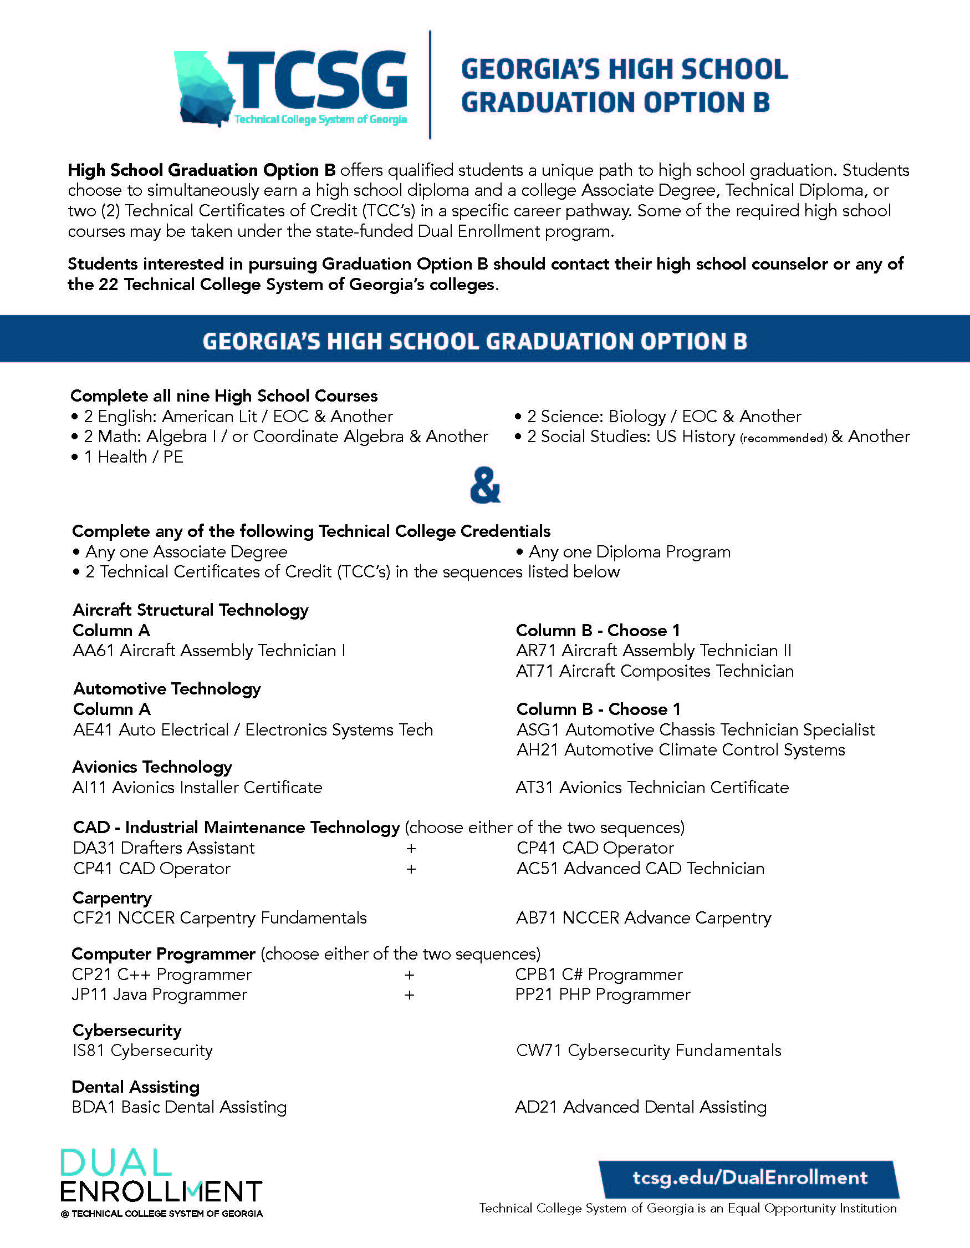
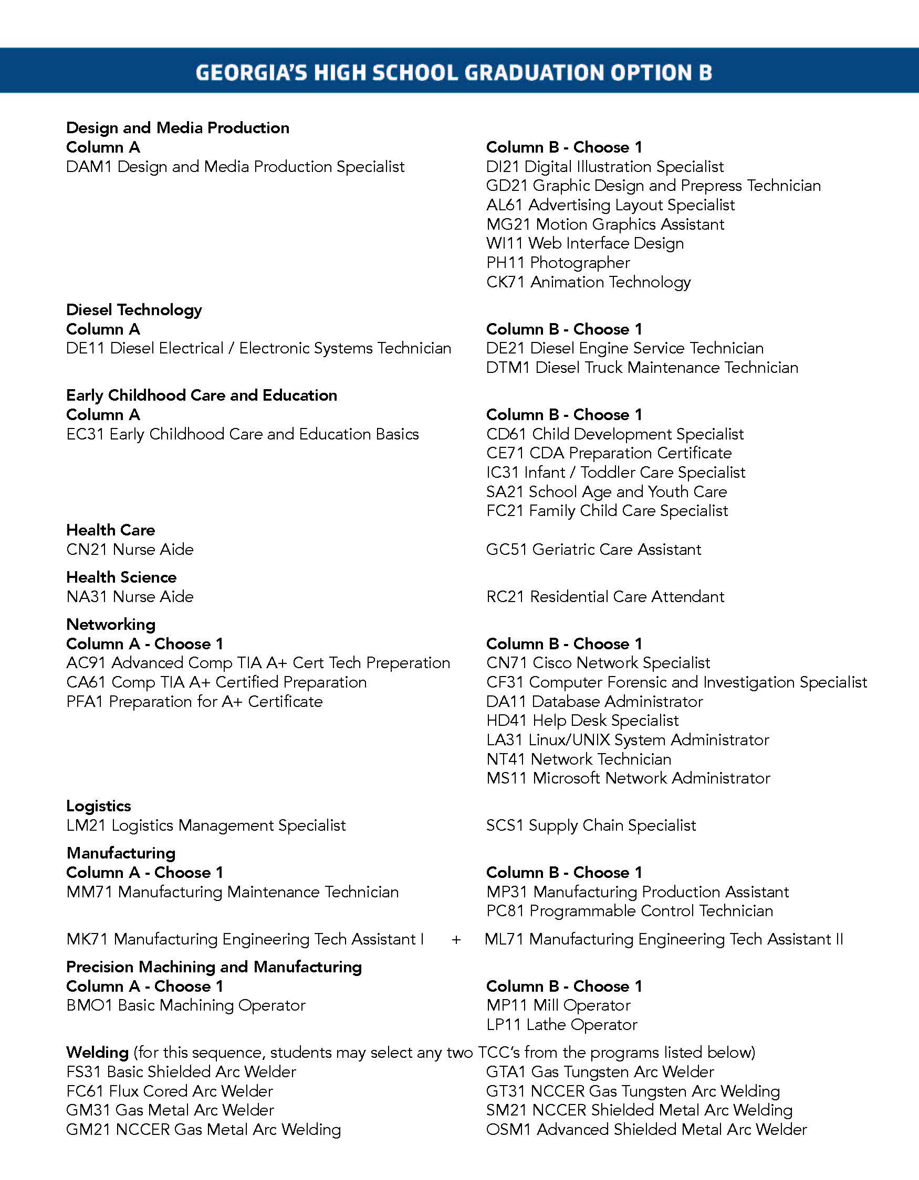

Section 4: FIELDS OF STUDY TO MEET EMPLOYER NEEDS

4.1 General

Subsection (b) of Senate Bill 2 requires TCSG to “annually identify fields of study in which a critical need or shortage of trained personnel exists in the labor markets in this state.” Districts should use this information “for the purpose of emphasizing areas of critical workforce needs and shortages in the labor markets in our state to high school students to support their career pathway decisions.”
Video from TCSG. TCSG stands ready to work with any district that wishes to add a new field of study/TCCs. Here is a link to a 2-minute video from Mr. Mark Peevy, Assistant Commissioner, explaining how it works: https://youtu.be/_6Qcwqdb96Q

As a practical matter, rather than focusing on statewide needs, districts typically work with the local technical college and local or regional employers to determine the employers’ needs.
If there is a field of study/TCCs on the approved list that would meet the needs of local employers, but the local technical college does not offer those TCCs, then the technical college should try to find a way to offer those TCCs. To aid in this process, the district and technical college should consider contacting the district and technical college that developed the TCC coursework. To determine whom to contact, please email Pam Tallmadge at pam@chareter-system.org and we will help you locate the individuals to contact.
Similarly, if there are no approved TCCs on the TCSG list that would meet the employers’ needs, then the technical college, district and employers should work together to create new TCCs and then request that TCSG add the new field of study/TCCs to the approved list. Several new fields of study/TCCs have been added just in the last year.
For example, Central Educational Center in Coweta County worked with West Georgia Technical College to address the need for more dental assistants. West Georgia Tech asked TCSG to add the two existing Dental Assisting TCCs, which had been developed especially to support dual enrollment, as a new field of study on the Option B list. TCSG approved this new pathway in 2020.
As another example, Foothills Charter High School/Walton County worked with Athens Technical College to create coursework for a new field of study in Precision Machining and Manufacturing. In January 2021, TCSG approved three new TCCs for this new field of study. In support of this request, Foothills/Walton County/Athens Tech submitted the checklist presented in Section 6.3 below.
A challenge in providing new fields of study is finding qualified instructors. Keep in mind that charter systems and some strategic waiver districts have the flexibility to hire instructors that do not hold PSC certification. Current Option B districts have dealt with this challenge in a variety of ways, including:
- Qualify high school teachers as adjuncts for the technical college.
- Arrange for technical college instructors to come to the high school or CCA.
- Ask employers to provide instructors.
- Hire instructors on a part-time, independent contractor, basis.
- Consider virtual or hybrid instruction where appropriate.

4.2 Best Practices from Option B Districts

We posed questions to current Option B districts to find out how they went about identifying employers’ needs and setting up the needed TCCs to meet those needs. Here are the responses from 4 districts:
1. How did your district go about identifying the needs of regional and local employers? What are some of those needs? What TCCs, technical college diplomas and associate degrees have you found to be in demand by your employers?
Mr. Mark Whitlock (Central Educational Center, Coweta County) reports:
We work to locate and review data in multiple ways, particularly by placing our College and Career Academy on point to lead in this effort:
- Review placement data gathered by the Office of Institutional Effectiveness at WGTC. CEC works with this Office on a continuous basis to review the placement rate for each of the programs (TCCs, diplomas, etc.) to determine the level of employer need. As data flow in, CEC with adjust current programs to meet changing employer needs.

- Interview employers directly.

- Meet with companies, industry representatives referred by our stakeholders.

- Collect data gathered by Chamber of Commerce and Development Authority from companies to determine needs of employers.

- Interview other agencies, including DOL, WGTC Office of Institutional Effectiveness, Georgia Tech Enterprise Innovation Institute, to gather data from macro-economic forecasting groups with which they communicate, or to gather summary data from companies with which they consult.

- Review state economic development initiatives/state policy initiatives.

- Generally, CEC finds that the needs revolve around high-skill jobs/careers for which the pipeline of young (by age 18) talent is less than acceptable. The needs define CEC’s program offerings in the College and Career Academy. Increasingly, those program offerings sync with growing Option B program area lists, since "high demand" fields lack enough qualified applicants to fill available jobs. In particular, we find high demand for TCCs/diplomas/associate degrees in skilled positions in healthcare and manufacturing.

Ms. Pam Smith (Wiregrass Regional CCA, Coffee County) reports:
- Needs survey conducted by our partnering technical college.

- We have found needs in Welding, Healthcare, Precision Machine and Manufacturing.

Ms. Holly Durrence (Evans Region CCA) reports:
- A needs assessment was conducted. This 100-question assessment had 50 respondents.

- The top four areas of need were agribusiness, manufacturing, life sciences, and construction.

- We will open the Evans Region College and Career Academy in August.

- Welding is a high demand career. Certified nursing assistants and healthcare positions, in general, seem to be highly needed positions. Employers have also reached out about small engine mechanics, which there is limited training for apart from a short section of an automotive program which addresses small engine repair.

Ms. Laura Ergle (Griffin Region CCA, Spalding, Butts and Pike Counties) reports:
- We use survey and focus group meetings.

- Top needs: manufacturing, welding, and healthcare.

2. Have employers committed to helping with recruitment of Option B students? If so, how do they help? Do you have any employers that have committed to hiring Option B graduates?
Mr. Mark Whitlock (Central Educational Center, Coweta County) reports:
Employers help CEC recruit students for Option by:
- Meeting with groups in our high schools/ at our College and Career Academy.

- Meeting with parent groups that we have pre-arranged (virtually and in-person).

- Hosting meetings at the employment site to allow students and parents a closer look at opportunities.

- Providing short-term internships to allow students a chance to develop further interest.

- Providing job shadowing opportunities to allow students a chance to develop further interest.

- Employers also promise to hire CEC Option B graduates.

Ms. Pam Smith (Wiregrass Regional CCA, Coffee County) reports:
- No employers have committed to helping with recruitment at this time but it is something we would like to pursue.

- Employers have committed to hire Option B students after graduation.

Ms. Holly Durrence (Evan County Regional CCA) reports:
- Currently, we are "educating" all stakeholders about the college and career academy initiative and Option B opportunities

- Even though we are in our third year of offering Graduation Option B, only a few students have reached completion of the requirements. Moving forward, we will need to track this type of information to determine our impact.
Ms. Laura Ergle (Griffin Region CCA, Spalding, Butts and Pike Counties) reports:
- Welding is our largest Option B and no recruitment needed, manufacturers assist with tour and info sessions.
- Most employers are happy to commit to hiring Option B students.

3. Have you worked with your technical college and TCSG to create any new TCC’s? If so, what TCC(s) were created? How did you go about that process?
Mr. Mark Whitlock (Central Educational Center, Coweta County) reports:
CEC has worked with WGTC to add TCCs in Precision Manufacturing and Maintenance which were created as they gathered business and education stakeholders in the effort to stand-up the Advanced Maintenance Technician (apprenticeship) program. The steps they took included:
- We first listened to employers. They asked for "German Apprenticeship to train the Industrial Mechanic/Advanced Manufacturing Technician."

- Then we reviewed available standards with WGTC, with TCSG and with the GACC, matching those with standards needed in order to locate gaps.

- That "crosswalk" led directly to the creation of TCCs/diploma/associate degree.

- It took approximately one year to ready the TCCs/diploma/associate degree for use in instruction.

Ms. Pam Smith (Wiregrass Regional CCA, Coffee County) reports:
- None at this time.

Ms. Holly Durrence (Evan County Regional CCA) reports:
- We are currently working with Ogeechee Technical College to add three possible TCCs in diesel technology, healthcare, and manufacturing. This process began with discussion between our school and OTC about our workforce needs and students' interests. From there, Ogeechee Tech took over, first evaluating their program offerings and designing possibilities for the additional TCCs. The next step is to gain approval from the TCSG.
Ms. Laura Ergle (Griffin Region CCA, Spalding, Butts and Pike Counties) reports:
- None yet.
4. How have you gone about finding instructors? Do you have any high school teachers approved as adjuncts for the technical college? Do technical college instructors come to your high school or college and career academy?
Mr. Mark Whitlock (Central Educational Center, Coweta County) reports:
- We have utilized instructors already on WGTC staff and have worked with WGTC to hire additional professionals with industry experience to new instructor roles.

- We have had high school teachers approved as adjuncts in years past, but none currently fill those adjunct roles.

- We built our College and Career Academy to house WGTC labs needed in our community, so our College and Career Academy includes high school and college programs. WGTC technical instructors serve all WGTC students (high school and adult) in those labs.

Ms. Pam Smith (Wiregrass Regional CCA, Coffee County) reports:
- Our welding instructor is hired by TCSG but housed on our side of the building. We have 52 students in welding this semester.

- Also, our healthcare instructor is a former RN who is also a certified teacher. She is credentialed by Wiregrass Ga Technical College.

- It is imperative to find instructors that understand how to teach and connect with high school students.
Ms. Holly Durrence (Evan County Regional CCA) reports:
- We have hired/will hire industry experts in several of the areas. Currently, we have two adjunct professors. Both teach academic courses.

- Technical college instructors teach on our campus as well.
Ms. Laura Ergle (Griffin Region CCA, Spalding, Butts and Pike Counties) reports:
- Most of instructors are from TCSG, and they are still hard to come by.
- Most instructors host classes on our campus – with the exception of auto, film and programming.

Section 5: SCHEDULING

Building schedules for Option B students should be an individualized process. Each student has unique needs and circumstances, and the postsecondary course requirements vary greatly depending on whether the student is pursuing an associate degree, technical college diploma or two-TCCs. Even within the two-TCC path there is variability. Additionally, the schedule should make room for internships, apprenticeships, and work-based learning with local employers.
The following discussion explains how a schedule could/should be built for the 8 academic high school courses plus health/PE and then gives examples as to how postsecondary courses and work experience can then built into the schedule.

5.1 Scheduling Nine (9) High School Courses

There are, of course, many ways to build a schedule for an Option B student to complete the eight (8) academic courses plus Health/PE, but there are important considerations that weigh in favor of the student completing the eight (8) academic courses by the end of 10th grade. Among those considerations are: (a) dual enrollment funding is available starting in 10th grade for technical courses, and (b) for certain programs, technical colleges and/or employers impose minimum age requirements.
To be clear, however, it is not a requirement for Option B students to complete the high school courses by the end of 10th grade. Depending on the circumstances, it might be advisable for a student to delay taking one or more high school courses to 11th or 12th grade.
Below is a discussion of how Evans County and the Central Educational Center (Coweta County) would typically build a baseline schedule for the required high school courses, so that the opportunity for post-secondary coursework and work experience with local employers can start in 10th grade.
Evans County, which operates based on a seven-period day, put together the following high school course schedule that can then be modified to meet the needs of each student.

Evans County High School Course Schedule
Block | Subject | 8th Grade | 9th Grade | 10th Grade | 11th Grade | 12th Grade
1 | Math | 8th Grade Math | Fdns. of Algebra | Algebra I (EOC) | Open for  post-secondary  courses  and  work.
2 | Science | HS Physical Science | Biology (EOC) | CTAE or Technical
3 | ELA | 8th Grade ELA | World Literature + World History Integrated | American L/C (EOC)
4 | Social Studies | GA History |  | U.S. History (EOC)
5 |  |  | 9th Grade Transition | CTAE or Technical
6 |  |  | Elective | CTAE or Technical
7 |  | Health/PE | Elective | CTAE or Technical

Explanatory Notes to Evans County Schedule:
- Math – the above schedule (with Foundations of Algebra in 9th Grade) is built for the student who may not have strong math skills and would want to delay taking Algebra I until 10th grade. An intermediate math student might take Algebra I in 9th Grade and Geometry or Advance Algebra in 10th Grade. An advanced math student could take Algebra I in 8th Grade.
- Science – Evans County will require all students to take Physical Science in 8th grade. If a student takes Physical Science in 8th grade, the student must take the EOC test so it can feed into CCRPI. The EOC test is not required if Physical Science is taken in high school.
- ELA and Social Studies – Evans offers “World Literature/World History Integrated,” a single course that would cover all the content standards for both World Literature and World History, thereby allowing one integrated course to provide one credit for ELA and one credit for Social Studies.
- CTAE/Technical Coursework - This schedule allows the student to complete a CTAE pathway or start technical coursework in 10th grade and then use 11th and 12th grade to focus on post-secondary courses and an internship/apprenticeship. An Option B student who completes a technical certificate will be counted as a CTAE pathway completer for CCRPI.
- 9th Grade Transition – Evans requires all ninth graders to take a Ninth-Grade Transition course during which students explore career pathways, take the You Science assessment and learn study skills.
As a charter system, Evans County has flexibility under Title 20 regarding seat time, scheduling, teacher certification, etc. that allows this schedule to be built. Strategic waiver systems should check their waivers to verify that they have the needed waivers.
The Central Educational Center (“CEC”) is a College and Career Academy serving Coweta County. It has been operating for more than 20 years and offers an extensive menu of career pathways, including Option B and a German apprenticeship program. It operates on a block schedule.
The schedule below shows how an Option B student at CEC would typically complete the eight (8) academic courses plus Health/PE.

CEC High School Course Schedule
GRADE | HIGH SCHOOL  COURSES |  | TECHNICAL COLLEGE
 | Semester 1 | Semester 2 | Semester 1 | Semester 2
9th | 1st block- 9th Lit/Comp 2nd block- Health/PE  3rd block- Algebra I 4th block- Env. Science | 1st block- Government  2nd block- Biology  3rd block- Elective  4th block- Elective
10th | 1st block- World History  2nd block- Geometry | 1st block- American Lit  2nd block- Elective | 3rd and 4th blocks – Open for technical courses, additional high courses or internship/apprenticeship.
11th | Open for technical courses, additional high school courses or internship/apprenticeship.
12th

5.2 Scheduling Postsecondary Courses

An associate degree generally requires 60-73 semester hours; a technical college diploma generally requires 37-59 semester hours; and a TCC generally requires 9-36 semester credit hours (see TCSG Board policy manual Section 5.1.6 and 5.1.6p).
When building a schedule for postsecondary courses, keep in mind that (a) funding in 10th grade is available only for technical courses (unless the student scores well ACT or SAT) and (b) funding over the 30-hour dual enrollment funding cap is available under HOPE Grant and/or HOPE Career Grant. For an explanation of how the funding works, see Section 7 below (“Funding for the Option B Student”).
To illustrate how scheduling post-secondary courses work, the following discussion will show examples of schedules for Welding, Dental Assisting, and Precision Manufacturing based on the programs offered by Central Educational Center and Evans County.
An Option B student with two TCCs could graduate early from high school and some may choose that route, but students should be encouraged to stay in high school until the end of their 12th grade so they can earn additional TCCs, establish work experience with local employers, work toward a technical college diploma or an associate degree, and/or take additional high school courses.
Welding is the most popular career field for Option B students. Welding skills are in high demand and the pay and benefits are good to excellent.
There are currently eight (8) TCCs approved in the welding Field of Study. A student may select any two of these TCCs:
FS31 Basic Shielded Metal Arc Welder GTA1 Gas Tungsten Arc Welder
FC61 Flux Cored Arc Welder GT31 NCCER Gas Tungsten Arc Welding
GM31 Gas Metal Arc Welder SM21 NCCER Shielded Metal Arc Welding
GM21 NCCER Gas Metal Arc Welding OSM1 Advanced Shielded Metal Arc Welder

CEC Welding Schedule
West Georgia Technical College offers welding TCCs and a welding diploma, but not a welding associates degree. It offers 4 of the approved welding TCCs:
Course |  | Technical Certificate (TCC)
Number | Description | FS31 Basic Shielded Metal Arc Welder | GM31 Gas Metal Arc Welder | GTA1 Gas Tungsten Arc Welder | OSM1 Advanced Shielded Metal Arc Welder
Weld 1000 | Introduction to Welding Technology | 4 | 4 | 4
Weld 1010 | Oxyfuel and Plasma Cutting | 4 | 4 | 4
Weld 1030 | Blueprint Reading for Welding Technology
Weld 1040 | Flat Shielded Metal Arc Welding | 4
Weld 1050 | Horizontal Shielded Metal Arc Welding |  |  |  | 4
Weld 1060 | Vertical Shielded Metal Arc Welding |  |  |  | 4
Weld 1070 | Overhead Shielded Metal Arc Welding |  |  |  | 4
Weld 1090 | Gas Metal Arc Welding |  | 4
Weld 1110 | Gas Tungsten Arc Welding |  |  | 4
Weld 1150 | Advanced Gas Tungsten Arc Welding
Weld 1151 | Fabrication Processes
Weld 1152 | Pipe Welding
Weld 1153 | Flux Cored Arc Welding
Various | Welding Elective |  | 4 | 4
Credit Hours for Individual TCC: |  | 12 | 16 | 16 | 12

As shown by the bottom row, the number of credit hours required to complete an individual TCC varies from 12 to 16 hours.
An important aspect of the welding TCCs is that they are “stackable.” Because of overlap in the courses (highlighted in yellow), a student could complete the first two TCCs with a total of 20 semester hours. The same student could complete the third TCC by taking Welding 1110 (highlighted in blue). Thus, a student can complete three TCCs with a total of 24 semester hours of coursework at West Georgia.
Below is how the CEC might typically build a schedule (using with the high school coarse schedule discussed earlier as the base) for a student to earn all four welding TCCs. The student would earn certificates FS31 and OSM1 (basic and advanced Shielded Metal Arc Welder) by the end of 10th grade, with option to take 2 more courses in 11th grade for two additional TCCs (GM31 Gas Metal Arc Welder and GTA1 Gas Tungsten Arc Welder). Note that almost all of 11th and 12th grades remain open for the student to pursue a technical college diploma in welding, work for local employers, or take additional high school courses.

CEC Welding Schedule (4 TCCs)
GRADE | HIGH SCHOOL COURSES |  | TECHNICAL COLLEGE COURSES
 | Semester 1 | Semester 2 | Semester 1 | Semester 2
9th | 1st block- 9th Lit/Comp 2nd block- Health/PF  3rd block- Algebra I 4th block- Env. Science | 1st block- Government  2nd block- Biology  3rd block- Elective  4th block- Elective
10th | 1st block- World History  2nd block- Geometry | 1st block- American Lit/Comp  2nd block- Elective | 3rd & 4th blocks-  WELD 1000  WELD 1010  WELD 1040  Completion of FS31 - Basic Shielded Metal Arc Welder (first in welding certificate sequence) | 3rd & 4th blocks-  WELD 1050  WELD 1060  WELD 1070  Completion of OSM1 - Advanced Shielded Metal Arc Welder (second in welding certificate sequence)
11th | Students may opt to take additional high school courses, additional technical college courses in Welding, or courses toward the Welding diploma. We have found employers in our community interested in pipe-welding and other skills that can be added to the required TCCs. Students may also opt to take a work-based learning internship. |  | Optional WELD courses:  WELD 1090 (Completion of GM31 Gas Metal Arc Welder, third in welding certificate sequence),  WELD 1110 (Completion of GTA 1 Gas Tungsten Arc Welder, fourth in welding certificate sequence)
12th | Students may opt to take additional high school courses, additional technical college courses in Welding, or courses toward the Welding diploma. We have found employers in our community interested in pipe-welding and other skills that can be added to the required TCCs. Students may also opt to take a work-based learning internship.

At West Georgia Technical College, the diploma in welding requires a minimum of 54 hours and the schedule would have to be built according. The coursework includes more hours in occupational courses, but also basic skill courses in Interpersonal Relations (EMPL 1000), Fundamentals of English I (ENGL 1010) and Foundations of Mathematics (MATH 1012). Note that the English I and Foundations of Mathematic courses are not required for the TCCs, but they are required for the diploma.
CEC Dental Assisting Schedule
As shown by the approved TCC list, the Dental Assisting field of study is comprised of a sequence of two TCCs: BDA1 Basic Dental Assisting and AD21 Advanced Dental Assisting. The dental assisting field of study was added in 2020 at the request of West Georgia Technical College and Central Educational Center (Coweta). West Georgia Tech does not offer either a diploma or associate degree in dental assisting.
The courses that make up the two TCCs for dental assisting are as follows (see West Georgia Tech website at http://westgatech.smartcatalogiq.com/2020-2021/Student-Catalog/Academic-Programs/School-of-Health-Sciences/Dental-Assisting/Basic-Dental-Assisting-Certificate-BDA1 and http://westgatech.smartcatalogiq.com/2020-2021/Student-Catalog/Academic-Programs/School-of-Health-Sciences/Dental-Assisting/Advanced-Dental-Assisting-Certificate-AD21):
Course |  | Technical Certificate (TCC)
Number | Description | BDA1  Basic  Dental Assisting | AD21  Advanced Dental Assisting
DENA 1050 | Microbiology and Infection Control | 3
DENA 1080 | Dental Anatomy | 5
DENA 1340 | Dental Assisting I: General Chairside | 6
DENA 1350 | Dental Assisting II: Dental Specialties EFDA Skills |  | 7
DENA 1390 | Dental Radiology |  | 4
DENA 1400 | Dental Practice Management |  | 2
DENA 1460 | Dental Practicum Management |  | 1
Credit Hours for Individual TCC: |  | 14 | 14

Unlike the welding TCCs, these dental assisting TCCs are not “stackable,” and the student would have to complete 28 hours to earn the two TCCs.

CEC Schedule for Dental Assisting (two TCCs)
GRADE | HIGH SCHOOL COURSES |  | TECHNICAL COLLEGE COURSES
 | Semester 1 | Semester 2 | Semester 1 | Semester 2
9th | 1st block- 9th Lit/Comp 2nd block- Health/PF  3rd block- Algebra I 4th block- Env. Science | 1st block- Government  2nd block- Biology  3rd block- Elective  4th block- Elective
10th | 1st block- World History  2nd block- Geometry  3rd block- Elective  4th block- Elective | 1st block- American Lit/Comp  2nd block- Elective  3rd block- Elective  4th block- Elective
11th | Students may opt to take additional high school courses, and/or additional technical college courses in Dental Assisting. We have found dentists in our community interested in additional clinical experience for dental assisting students. West Georgia Tech is working on additional clinical experience options and our work-based learning program is working with dental assisting on potential ways to implement those options. |  | 1st & 2nd blocks-  DENA 1050  DENA 1080  DENA 1340 | 1st & 2nd blocks-  DENA 1350  DENA 1390  DENA 1400  DENA 1460
12th | Students may opt to take additional high school courses, and/or additional technical college courses in Dental Assisting. We have found dentists in our community interested in additional clinical experience for dental assisting students. West Georgia Tech is working on additional clinical experience options and our work-based learning program is working with dental assisting on potential ways to implement those options.

In addition to scheduling, depending on the field of study and how it is set up, there will be additional logistical challenges. For Dental Assisting, for example, typically the student should be 17 years old. Mark Whitlock explains:
1. Student must provide her/his own transportation to clinical rotation site. It is more likely that a 17-year old can be prepared for that, in our experience.
2. Background checks are required in the program since students will be in contact with patients. As I understand it, background checks provide no information until age 17.
3. There are guidelines that allow 16 year olds to enter so long as their 17th birthday occurs very soon after entering the program.
4. Students could complete the two certificates in two semesters, since we can allow the student to attend the program for one-half day for each of two semesters, so, if they can start at the beginning of the junior year, they may have opportunity for additional work-based learning experience in the senior year. We have seen the value that provides for students. Dentists are looking for the student with as much clinical experience as possible. We may seek to add a third certificate, focused on clinical experience, that can be completed during the summer before or after the senior year. That won't be a requirement for Option B but will certainly add tremendous value for students.
Evans County Schedule for Welding (2 TCCs) (Seven Period Day)
For Evans County, which is on a seven-period day, the approach would be similar, except that instead of completing the welding TCCs during 10th grade, Evans would encourage the student to complete the TCCs over the course of 11th and 12th grades. The high school courses are highlighted in yellow and the technical coursework is highlighted in blue.

Evans County Schedule (2 TCCs)
Period | Subject | 8th Grade | 9th Grade | 10th Grade | 11th Grade | 12th Grade
1 | Math | 8th Grade Math | Fdns. of Algebra | Algebra I (EOC) | TCC 1 | TCC2
2 | ELA | 8th Grade ELA | World Literature + World History Integrated | American L/C (EOC)
3 | Social Studies | GA History |  | U.S. History (EOC)
4 | Science | H.S. Physical Science | Biology (EOC) | CTAE or Technical College
5 |  |  | 9th Grade Transition | CTAE or Technical College
6 |  |  | Elective | CTAE or Technical College
7 |  | Health/PE | Elective | CTAE or Technical College

More Complex Schedules – Advanced Manufacturing Apprenticeship (CEC)
There are many much more complex schedules that can be created.
As mentioned earlier, an associate degree generally requires 60-73 semester hours whereas a technical college diploma generally requires 37-59 semester hours.
An Option B student can complete a diploma while in high school whereas completion of associate degree is more challenging but it can be done.
At the CEC, the most complex schedule they have developed requires the student to study/work two summers and would result in the student earning several credentials in the Advanced Manufacturing Technician Apprenticeship:
- Three Manufacturing TCCs
- The German Apprenticeship Program Diploma
- Apprenticeship in 10th, 11th and 12th grades with $8-$12 per hour.
CEC is unique in offering the German apprenticeship program, but it could be built in other parts of the state. Employers have said that the students who complete this program are the best trained employees they have seen.
Here is a link to this schedule in Excel format: Central Educational Center Schedule for Manufacturing Apprenticeship
Note that at the bottom, the schedule states “Post High School – Begin Fulltime Employment and/or pursue AA degree.”

Section 6: RECRUITMENT AND COUNSELING

6.1 Video Resources

An excellent video that can be used for presentations to community groups, teachers, parents and students is entitled “Success in the New Economy” (10 min). This video was produced by a technical college in California. It explains the value of earning postsecondary technical credentials in today’s new economy. Seventy percent of the workforce requires technical certificates or associate degree for skilled technicians. Half of those who graduate with traditional 4-year degree are underemployed. https://www.youtube.com/watch?v=zs6nQpVI164
On February 9, 2021, the Foundation hosted a webinar for Counselors and Administrators. The panel discussion included Morris Leis (Superintendent) and Pam Smith (CEO of Wiregrass Regional CCA and former counselor) from Coffee County, Laura Ergle (CTAE Director, Griffin Region CCA), Mark Whitlock (CEO) and Dawn Revere (Counselor) from the Central Educational Center, Dianne Barker (Secondary Initiatives Coordinator) from TCSG, and Jennifer Phinney (Dual Enrollment Program Specialist) from GaDOE. Here is a link to the video recording, starting at the panel discussion: https://youtu.be/RWdwQIXaxmY?t=197 Much of the discussion in the following sections comes from this webinar.

6.2 The Role of Counselors

Counselors obviously play a critical role in the success of an Option B program. A district seeking to implement Option B needs to make sure its counselors are aware of the benefits of Option B. As Pam Smith (Coffee County) recently observed:
“Counselors need to be trained about the benefits of Option B. There still seems to be some reluctance in encouraging students to pursue this route. Even with the 30-hour cap, two welding TCC's only use 12 hours and the students have credentials to take into the workforce. If they want to continue in welding or healthcare beyond the 30 hours they can use the HOPE Career Grant. We have had students use it this year and it was not difficult to apply for.”
For a high school with a larger student population and several counselors, it is difficult to assure that all the counselors have equal training and understanding of Option B. Recognizing this challenge, Dawn Revere (Counselor, Central Educational Center, Coweta County) serves as the point person for counseling Option B students. The other counselors rely on her. Both Jennifer Phinney (DOE) and Dianne Barker (TCSG) agree that this should be viewed as a “best practice.” Dual enrollment, and in particular, Option B, can be complicated and it helps to have one person with a deep understanding serve as the “point” and take the load off the other counselors.
The current Option B districts agree that counselors should develop a graduation plan for each student (including a customized schedule as discussed in Section 5 on Scheduling above).
It is critically important that counselors form a close working relationship with the high school coordinator at the local technical college, for the purpose of building the student’s schedule, keeping abreast of employer needs, and monitoring the student’s progress at the technical college.
In a PowerPoint Pam Smith shows to eighth grade students and their parents each year, there is a slide that lists counselor responsibilities (Pam Smith PowerPoint to 8th Graders (Coffee County)):
School Counselor Responsibilities
- Provide general DE information by February 1st of each year
- Provide student advisement and complete/sign-off on the Student Participation Agreement
- Complete the counselor’s portion of the online funding application
- Students and Parents should be made aware of the local school system policy regarding the withdrawal from DE courses and impact on the student’s transcript.
- Record courses and grades on student’s transcript for dual enrollment credits earned.
- Encourage students to be mindful of deadlines and graduation requirements

6.3 Counselor Checklists

Counselors may want to develop general Option B checklists for counseling students and parents. GaDOE has published an Option B checklist which appears on the next page.

Note that above Checklist shows a requirement of 2 credits for Social Science, and it lists World Hist or U.S. History or Economics and Government as options. Actually, an Option B student may choose any two Social Science courses and is not limited to these choices. The more up-to-date list of approved TCCs at page 13 above shows this requirement: “2 Social Studies: US History (recommended) & Another.” US History is recommended but not required.
Counselors may want to generate a checklist for that is specific to each Option B field of study offered to the district’s students. The next few pages show specific checklists developed by Foothills/Baldwin County for welding and a checklist developed by Foothills/Walton County for the new precision machining and manufacturing pathway recently approved by TCSG. You may want to use these as guides to generate your own checklists.

FOOTHILLS/BALDWIN COUNTY OPTION B HIGH SCHOOL DIPLOMA PATH – Welding (Two TCCs: Basic Shielded Meta ARC and Gas Metal ARC)
HIGH SCHOOL REQUIREMENTS:
English  ☐ American Lit (w/EOC)  ☐ Plus 1 ELA Course | Mathematics  ☐ Algebra I/Coord. Algebra (EOC)  ☐ Plus 1 Math | Science  ☐ Biology (EOC)  ☐ Plus 1 Science Course
Social Studies  ☐ 1st Social Studies  ☐ 2nd Social Studies  *If US History is chosen, an EOC is required. | ☐ Health/PE | Technical College  ☐ Diploma OR  ☐ Degree OR  ☐ 2 Approved Technical College Certificates – Welding below

REQUESTED POST-SECONDARY REQUIREMENTS: TWO TCC’S

REQUIRED TCC  Fall 2021 | Second TCC for Option B  Spring 2022
BASIC SHIELDED METAL ARC WELDER (FS31)  Certificate of Credit Prepares students for careers in the welding and joining industry.  This certificate emphasizes arc welding in the flat position and is pre-requisite to the advanced certificate.  WELD 1000 Introduction to Welding Technology  WELD 1010 Oxyfuel and Plasma Cutting  WELD 1040 Flat Shielded Metal Arc Welding (Spring) | GAS METAL ARC WELDER (GM31)  Technical Certificate of Credit Prepares students for welding careers in the MIG process. Topics include an introduction to welding technology, oxyfuel cutting techniques, and MIG welding techniques and processes.  WELD 1090 Gas Metal Arc Welding (Spring)  Complete WELD 1040 Flat Shielded Metal Arc Welding from FS31 TCC

WORK BASED LEARNING AND ADDITIONAL TCC HOURS:
- Students encouraged to participate in WBL while in high school and complete additional TCCs offered by Central Georgia Tech. Dual Enrollment Cap of 30 hours and access to HOPE Career Grant funds will pay costs of completion.

POST HIGH SCHOOL GRADUATION:
- Upon graduation – complete AA degree funded through HOPE Grant – HOPE Scholarship eligibility upon AA Degree Completion.

FOOTHILLS/WALTON COUNTY OPTION B HIGH SCHOOL DIPLOMA PATH – PRECISION MACHINING AND MANUFACTURING TECHNOLOGY - Beginning Summer 2021.
HIGH SCHOOL REQUIREMENTS:
English  ☐ American Lit (w/EOC)  ☐ Plus 1 ELA Course | Mathematics  ☐ Algebra I/Coord. Algebra (EOC)  ☐ Plus 1 Math | Science  ☐ Biology (EOC)  ☐ Plus 1 Science Course
Social Studies  ☐ 1st Social Studies  ☐ 2nd Social Studies  *If US History is chosen, an EOC is required. | ☐ Health/PE | Technical College  ☐ Diploma OR  ☐ Degree OR  ☐ 2 Approved Technical College Certificates (PMMT BELOW)

REQUESTED POST-SECONDARY REQUIREMENTS: TWO TCC’S – 26 CREDIT HOURS REQUIRED
REQUIRED TCC | CHOOSE ONE:  MILL OPERATOR TCC OR  LATHE OPERATOR TCC
BASIC MACHINING OPERATOR TCC (22)  MCHT 1011 – INTRO TO MACHINE TOOL (4) MCHT 1012 – BLUEPRINT FOR MACHINE TOOL (3)  MCHT 1020 HEAT TREATMENT AND SURFACE GRINDING (4)  MCHT 1119 LATHE OPERATIONS I (4)  MCHT 1120 MILL OPERATIONS I (4)  MCHT 1013 MACHINE TOOL MATH (3) | MILL OPERATOR (4)  MCHT 1220 – MILL OPERATIONS II (4)  OR  LATHE OPERATOR (4)  MCHT 1219 LATHE OPERATIONS II (4)
WORK BASED LEARNING AND ADDITIONAL TCC HOURS:
- Students encouraged to participate in WBL while in high school and complete additional TCCs offered by Athens Tech for PMMT. Dual Enrollment Cap of 30 hours and access to HOPE Career Grant funds will pay costs of completion.
POST HIGH SCHOOL GRADUATION:
- Upon graduation – complete AA degree funded through HOPE Grant – HOPE Scholarship eligibility upon AA Degree Completion.
BACHELOR’S DEGREE OPPORTUNITY: COMPLETION OF AA DEGREE IN PRECISION MACHINING AND MANUFACTURING TECHNOLOGY IS A 2+2 PROGRAM WITH KENNESAW STATE UNIVERSITY – BACHELOR OF APPLIED SCIENCE MANUFACTURING OPERATIONS.
https://engineering.kennesaw.edu/systems-industrial/degrees/bas-manufacturing-operations.php
Precision Machining and Manufacturing Technology two TCC part B Option with a Summer Start.
Basic Machining Operator TCC (Major Code: BM01)
Mill Operator TCC (Major Code: MP11)
Semester | Class | TCC Major Code | Credit Hours | Class and lab hours
Summer | MCHT-1011 | BM01 and MP11 | 4 | 4:00 to 7:00 pm Tuesday and Thursday with optional lab Friday from 9:00 to 1:00 pm
Fall | MCHT-1012 | BM01 and MP11 | 3
 | MCHT-1119 | BM01 | 4
 | MCHT-1120 | BM01 and MP11 | 4
Spring | MCHT-1013 | BM01 | 3
 | MCHT-1020 | BM01 | 4
 | MCHT-1220 | BM01 and MP11 | 4
 |  | Total Credit Hours | 26

Precision Machining and Manufacturing Technology two TCC part B option with a Fall Start.
Basic Machining Operator TCC (Major Code: BM01)
Mill Operator TCC (Major Code: MP11)

Semester | Class | TCC Major Code | Credit Hours
Fall | MCHT-1011 | BM01 and MP11 | 4
 | MCHT-1012 | BM01 and MP11 | 3
 | MCHT-1119 | BM01 | 4
Spring | MCHT-1013 | BM01 | 3
 | MCHT-1120 | BM01 and MP11 | 4
 | MCHT-1220 | BM01 and MP11 | 4
Summer | MCHT-1020 | BM01 | 4
 |  |  | Total Credit Hours 26

6.4 Recruiting Option B Students

Counselors also play a key role in educating students, parents, teachers and administrators about the Option B pathway, as discussed more fully in below.
The current Option B districts agree that, if provided the proper information to make decisions, Option B students have a keen sense of direction and know that Option B is the most logical path for them. Option B gives the students purpose and direction.
Option B districts agree that it is important reach out to students, parents, teachers, and counselors in middle school or even elementary school to identify students who would be good candidates for Option B. At the same time, it is also important to reach out and “capture” students in 10th, 11th and even 12th grade who become disengaged and would benefit from jumping on the Option B pathway (see Section 6.5 below “Best Dropout Prevention Tool”).
The current Option B districts use various approaches to recruit students and their parents.
Coffee County currently has 50 students in the welding program and 7 students pursuing an associate degree under Option B.
Pam Smith (Coffee County) meets every year with all eighth-grade students and their families. She says the parents and students are very excited to learn that the Option B is available as an alternative to the traditional academic pathway for a high school diploma. Here is a link to the PowerPoint she uses for the presentation: Pam Smith PowerPoint to 8th Graders (Coffee County) Other districts could draw some ideas from this presentation.
Ms. Smith also sets up an “open campus” day at the college and career academy so younger students and their families can tour the facilities, including the labs. Often community members will show up.
Dawn Revere (CEC, Coweta County) explains some of the methods CEC uses to reach out to students and their parents:
- Conduct Option B Night(s) each year for students and parents (usually 300 in attendance)
- Attend MS faculty meetings to educate teachers about Option B, and the teachers in turn can identify students who would be good candidates.
- Visit classrooms to make presentations to the students.
- Run ads in the local newspaper.
One of the most popular parts of the Option B Night is a panel discussion by current and former Option B students and parents. Here is a link to a recording of one of panel discussion from 2019: https://www.youtube.com/watch?v=RfHr8fdfO0Y This video is worth watching, and perhaps could be used by other districts to show to students and parents what other students and parents are saying.
Additionally, CEC has an 8th grade academy for students interested in pursuing a career-oriented pathway.
Evans County reaches out to students as early as elementary school and they require all 9th grade students to take a 9th Grade Transition Course during which students explore career pathways, take the You Science assessment and learn study skills. All the Option B districts agree that it is important to have instruments such as You Science that can measure the interests of the students and match them will a good career pathway.
Evans County developed a PowerPoint that it uses for presentations to students, parents, employers and community groups. Here is a link: Evans County PowerPoint - Pipeline and Option B
Other districts might find it helpful to review this presentation for ideas as to how they might develop their own presentation. One of the slides shows the pipeline that Evans County is developing to educate students and parents about career-oriented pathways such as Option B:
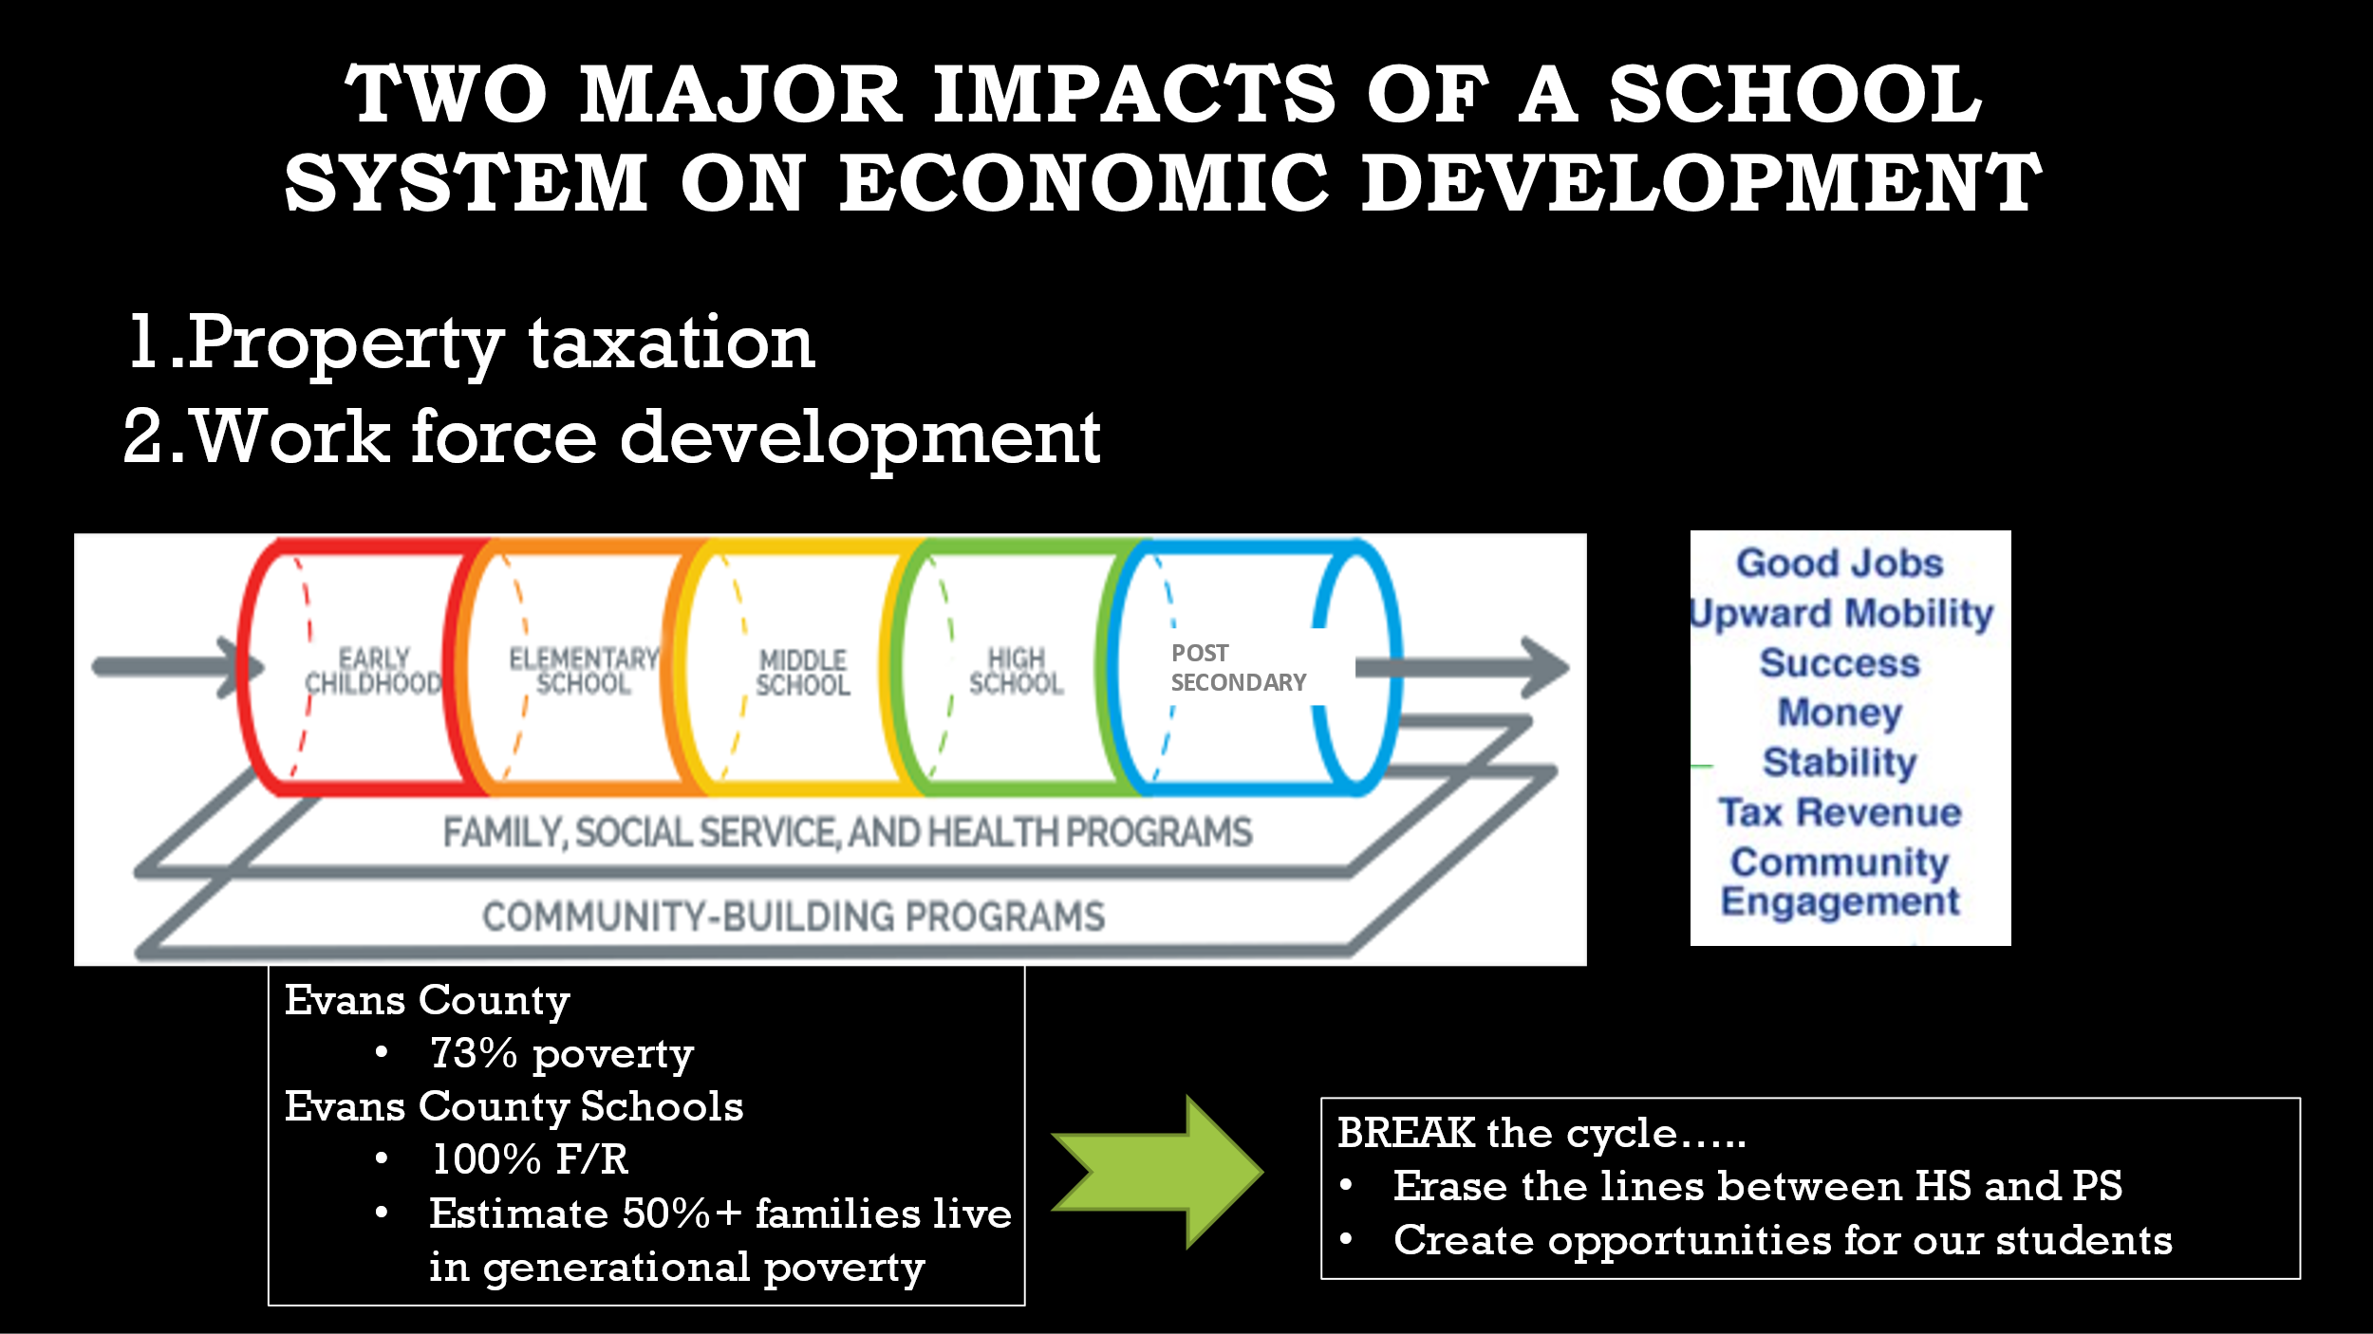

As Superintendent Marty Waters says, if a student from a family with generational poverty can earn Option B credentials, graduate from high school debt free, and start work in a well-paying career, it is transformative for that student and the student’s family.
It is also important that local employers help with the recruitment of students. Parents and students need to hear directly from employers. Employers should attend meetings with students and parents to describe the jobs for which they intend to hire students with Option B credentials.
Laura Ergle (Griffin Regional CCA) points out that many parents and students perceive incorrectly that manufacturing plants are dirty and not safe. She works with local manufacturers arrange tours of plants for parents and students, which can be an eye-opening experience.

6.5 “Best Dropout Prevention Tool”

Option B was designed primarily to allow a student to earn postsecondary credentials that will lead to employment in a high demand field. Ideally, with proper recruitment efforts in middle school and 9th grade, students will be able to decide then whether to pursue an Option B pathway. As will be discussed in the next section, Option B can also serve as a pathway to college, but it also has been described as “the best dropout prevention tool.”
For students who become disengaged with the traditional academic track during high school, Pam Smith (Coffee County) explains that Option B provides an attractive alternative with hands-on training that leads to a high school diploma and credentials needed for a well-paying career.
Laura Ergle (Griffin Regional CCA) agrees that Option B serves as a highly effective dropout prevention tool. As an example, a high school student could earn two welding TCCs as late as the second semester of senior year and graduate assuming the student has completed the required 9 high school courses. This option at least prepares the student for a job in a high demand field.
Typically, when a district first decides to implement Option B, a good starting point is to identify disengaged high school students and counsel them to shift to the Option B path. At the same time, the district should start building a pipeline that will allow younger students to consider what path is best for them before they even enter high school.
The current Option B districts emphasize that an Option B student can easily get back onto the regular academic Option A path without much difficulty. In fact, Laura Ergle (Griffin Regional CCA) explains that she has had 3 Option B change their minds, and the counselors simply put them back on the Option A path.
Moreover, she explains students can complete two or more TCCs and at the same time take core academic courses (e.g., Economics, American Lit, English 1101, etc.) that meet the requirements of an academic HS diploma. There is plenty of room in the schedule to do this, as shown by the sample schedules in Section 5 “Scheduling” above.

6.6 “Pathway to College”

Option B students must earn “postsecondary” credentials (TCCs, Technical College Diploma, or Associate Degree) to qualify for an Option B high school diploma. Thus, by definition, the Option B student is on a “college” pathway in high school. One attribute of Option B is that the postsecondary credentials are “stackable credentials,” i.e., 2-3 TCCs provide a “base” for a technical college diploma and in turn an associate degree can stack on top of that. On the other hand, an Option B student might decide from the beginning that they want to earn Associate Degree while in high school.
Coffee County currently has 7 Option B students who are pursuing an associate degree. These students can easily move on to a four-year college if they so choose. Students who receive a high school diploma with 2 or more TCCs can pursue a Technical College Diploma or an Associate Degree after high school, and then move on to a 4-year degree if they so choose.
Laura Ergle (Griffin Regional CCA) emphasizes that Option B students can pursue a technical college diploma or associate degree (or even 2 or more TCCs) with a plan to continue to continue postsecondary work after high school.
Mark Whitlock, (Central Educational Center) explains that students also use Option B as a pathway to college. As shown by the Advanced Manufacturing Technician program discussed in Section 5.5 above, a student can earn three Manufacturing TCCs, the German Apprenticeship Program Diploma, and earn $8-$12 per hour in the apprenticeship program in 10th, 11th and 12th grades. CEC encourages students to continue with the Associate Degree post high school if they so choose. Mr. Whitlock explains that taking this pathway could become the “norm” for students interested in engineering. He likes to point out that CEC’s first Option B graduate earned a full ride to the University of West Georgia Honors Program.

Section 7: FUNDING
With the state-funded Dual Enrollment program and the lottery-funded HOPE Grant and HOPE Career Grant programs, all or most of the cost of the postsecondary courses taken by an Option B student may be covered. The students must meet the eligibility requirements for each program. Dual Enrollment now has a 30-semester hour Funding Cap. Once Option B students have reached the Funding Cap, they may qualify for the HOPE Grant and HOPE Career Grant.
With the implementation of the Funding Cap and Grade Level eligibility, the 4-year length of eligibility was eliminated. Students that are 5th year seniors may participate in Dual Enrollment and qualify for funding (they must meet all eligibility requirements).
Visit www.GAfutures.org for more information and the applications for the Dual Enrollment Funding, HOPE Grant, and HOPE Career Grant programs.
The Foundation has developed model PowerPoint slides as of September 2021 and tables that graphically explain funding for Option B, which can be a bit convoluted. We hope that you will agree that the graphics in the PPT will help counselors, students and parents more easily visualize and understand how funding for Option B works. The Model PowerPoint can be downloaded from the Option B Resource Center, or here is a link:
Pennie Strong, Vice President, Program Administration for GSFC did an excellent presentation as part of the Foundation’s March 4, 2021 webinar on “Funding and Programs of Study.” Participants also asked many good questions.
We recommend that districts watch the video of Ms. Strong’s presentation or download the PPT and read through a transcript of her presentation:
Watch Presentation: https://youtu.be/uDu1oGdY8jk?t=225
Download Ms. Strong’s PowerPoint: Dual Enrollment Charter-after Funding Cap
Download Transcript of Presentation: Transcript of Pennie Strong Presentations 3/4/21 on Option B Funding
If you have any questions about funding, please send them to Pam Tallmadge at pam@charter-system.org and we will help obtain answers. Please funnel your questions through the Foundation, so we will be able to add the answers to our knowledge bank and share the information with other districts.

Code Section 20-2-161.3 is the Dual Enrollment Act.
Paragraph (7) of Code Section 20-3-519 defines eligible postsecondary institution as follows: (7) "Eligible postsecondary institution" means a school which is: (A) A unit of the University System of Georgia; (B) A branch of the Technical College System of Georgia; (C) A private independent nonprofit postsecondary institution eligible for tuition equalization grants in accordance with the provisions of subparagraph (A) of paragraph (2) of Code Section 20-3-411; or (D) A private proprietary postsecondary institution eligible for tuition equalization grants in accordance with the provisions of subparagraph (B) of paragraph (2) of Code Section 20-3-411.

