Name _____________________ Local School Governance Team (LSGT) ___________________

“Pulse Check” on School Improvement
Directions: Select the best answer by choosing a, b, c, or d.

- School Improvement typically is overseen by the
  - Assistant Superintendent for Finance
  - Assistant Superintendent for Human Resources
  - Assistant Superintendent for Business Operations
  - Assistant Superintendent for Instructional Services
- The innovations and priorities of LSGTs
  - Must complement and support School Improvement Plans
  - Do not necessarily have to align with School Improvement Plans
  - Never align with School Improvement Plans
  - Must compete with School Improvement Plans
- The school district engages in long-term planning with a plan of
  - 5 to 10 years
  - 3 to 5 years
  - 1 to 5 years
  - 2 to 7 years
- The district strategic plan’s goals and objectives
  - Can only be measured anecdotally
  - Can be measured anecdotally or with data
  - Must be measured with data
  - Can only be measured by teacher reviews
- School improvement planning data can include
  - Demographic data
  - Student achievement data
  - Process data
  - All of the above
- For a typical School Improvement Plan timeline, the LSGTs should provide feedback in
  - June
  - September
  - January
  - May
- The district leadership develops and implements the District Strategic Plan, this an example of
  - Management
  - Governance
  - Both A and B
  - Neither A nor B

- What is the first key step in the typical timeline and process for School Improvement Planning?
  - Data analysis
  - LSGTs approve plans
  - Draft School Improvement Plans
  - Implementation

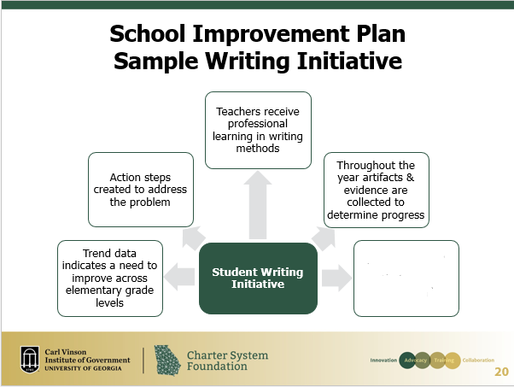

- Refer to the slide above. What is the missing step in this sample writing initiative?
  - Teachers are certified in teaching student writing
  - Teachers collect student journals for grading
  - Instruction begins
  - Summative and formative assessments are analyzed

